Trochee

🔹 What is Trochee
# Source: AI Source: Provided by: [Data Path: Persons Table -> ID Column: 1, Name_En Column: Motasem Essam] -> From: [Chatgpt (GPT-4-turbo)] on [8/3/2025]
A trochee is a metrical foot consisting of two syllables:
- The first syllable is stressed, and the second is unstressed:
— ◡
This gives the rhythm a falling or descending effect, opposite to the iamb.

✅ Syllable Pattern:
# Source: AI Source: Provided by: [Data Path: Persons Table -> ID Column: 1, Name_En Column: Motasem Essam] -> From: [Chatgpt (GPT-4-turbo)] on [8/3/2025]
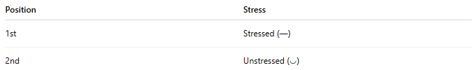
Position | Stress
1st | Stressed (—)
2nd | Unstressed (◡)

✅ Examples of Trochaic Words or Phrases:
# Source: AI Source: Provided by: [Data Path: Persons Table -> ID Column: 1, Name_En Column: Motasem Essam] -> From: [Chatgpt (GPT-4-turbo)] on [8/3/2025]
- TAble
- NEver
- DOCtor
- GARden
- SONnet
Each of these starts with a stressed syllable followed by an unstressed one.

✅ Function in Poetry:
# Source: AI Source: Provided by: [Data Path: Persons Table -> ID Column: 1, Name_En Column: Motasem Essam] -> From: [Chatgpt (GPT-4-turbo)] on [8/3/2025]
The trochee is often used to create a forceful, emphatic rhythm, sometimes with a haunting or chant-like quality.
Common in:
- Trochaic tetrameter (4 trochees per line)
- Children’s rhymes and chants
- Magical or incantatory language

✅ Famous Example – Trochaic Tetrameter:
# Source: AI Source: Provided by: [Data Path: Persons Table -> ID Column: 1, Name_En Column: Motasem Essam] -> From: [Chatgpt (GPT-4-turbo)] on [8/3/2025]
From Shakespeare’s Macbeth (Witches’ Chant):
DOUble, / DOUble, / TOIL and / TROUble;
— ◡ / — ◡ / — ◡ / — ◡
Each foot is a trochee.

✅ Contrast with Other Feet:
# Source: AI Source: Provided by: [Data Path: Persons Table -> ID Column: 1, Name_En Column: Motasem Essam] -> From: [Chatgpt (GPT-4-turbo)] on [8/3/2025]
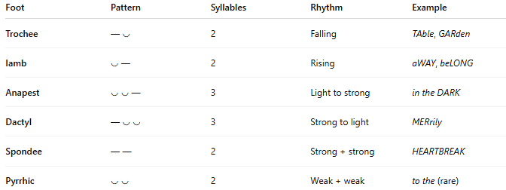
Foot | Pattern | Syllables | Rhythm | Example
Trochee | — ◡ | 2 | Falling | TAble, GARden
Iamb | ◡ — | 2 | Rising | aWAY, beLONG
Anapest | ◡ ◡ — | 3 | Light to strong | in the DARK
Dactyl | — ◡ ◡ | 3 | Strong to light | MERrily
Spondee | — — | 2 | Strong + strong | HEARTBREAK
Pyrrhic | ◡ ◡ | 2 | Weak + weak | to the (rare)

📝 Summary:
# Source: AI Source: Provided by: [Data Path: Persons Table -> ID Column: 1, Name_En Column: Motasem Essam] -> From: [Chatgpt (GPT-4-turbo)] on [8/3/2025]
- Trochee = stressed + unstressed syllable (— ◡)
- Used for a bold, falling rhythm
- Key meter in trochaic tetrameter
- Common in incantations, rhymes, and strong rhythms

